When firing off API requests, you should take care to make sure that your interface won't allow users to send the same request again while waiting for a response. This can be accomplished in a few different ways - for actions that create or destroy data (like "New invoice" or "Delete this user"), make sure to disable the action buttons and menu items that can trigger that behavior, until it is complete. Complete can mean either a success or a failure, so remember not to keep that button disabled if something failed.

For less destructive actions (like refreshing a list, for example), using something like a debounce function to limit the number of API calls users are able to send is advisable. A well-crafted API will reject rapidfire responses with a rate limiter of some sort, explained elsewhere in the book. Your interfaces can interpret such responses and dynamically enable/disable bits of interface accordingly, while providing meaningful messages for your users.

You may also have the luxury of using or building APIs that provide something like Stripe’s Idempotency Key. This allows you to annotate your request with a unique key, so that even if your request is sent to an API multiple times, it will only ever be executed once.

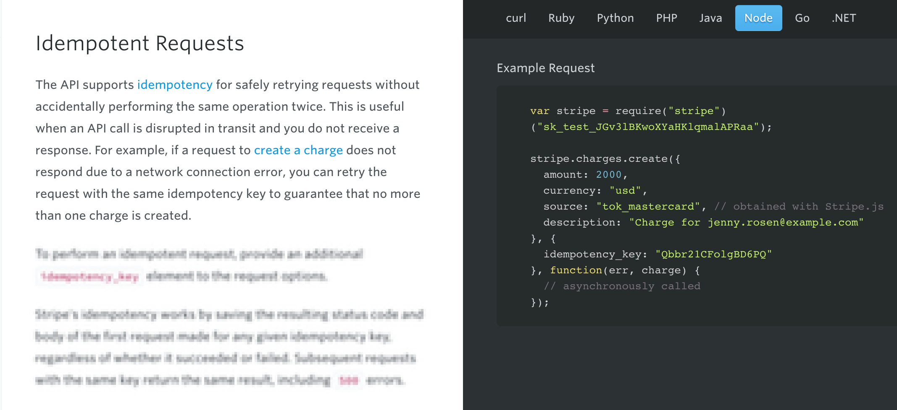
Stripe’s Idempotentcy strategy helps stop API consumers from accidentally creating the same credit card charge more than once.

